GTR70E WYVERN (Widespread Yield Variable Engagement Rapid-response Neutralizer): Engineering Design and Experimental Validation of Closed-Loop Thrust-Vector Control, Hybrid Passive–Active Stability, and Zoned Additive-Manufacturing Materials in a Subscale Single Stage Solid-Fuelled Prototype Rocket Demonstrator

Allison Hong, Chris Liu, Swaroop K. Sahoo
April 20th, 2026

Table of Contents
Table of Contents 1
Student Information 2
Introduction 2
Research Questions 3
Research Question 1 - Magnetic Solenoid vs. Servo Actuation 3
Research Question 2 - Structural Performance in 3D Printable Materials 3
Research Question 3 - Aerofoil Profile Efficiency for Subsonic Control 3
Research Question 4 - Wind Tunnel Calibration with In-Situ Performance 3
Research Question 5 - Accuracy of Flight Control Loop Architectures 4
Project Goal 4
Proposed Methodologies 4
Expected Outcomes 8
References 9
Abstracts 13
Swaroop Sahoo 13
Evaluating the Efficiency, Practicality, and Effectiveness of Emission/Reception-Capable LiDAR and RaDAR Detection Systems in Autonomous Navigation 13
Chris Liu 14
In-Situ resource utilization-derived iron perchlorate redox flow battery for Mars: electrolyte characterization and extreme cold performance validation 14
Allison Hong 15
The Effects of Different Types of Synthetic Retinoids on Bacteria Inhibition: Antibacterial Properties 15

Student Information
Student Names: Swaroop Sahoo, Chris Liu, Allison Hong

Project Title: GTR70E WYVERN: Engineering Design and Experimental Validation of Active Flight Control, Materials, Aerodynamic Optimization, and Wind Tunnel Evaluation in a Subscale-Demonstrator Autonomous Guided Rocket

Research Pathway: Engineering/Innovation Design

Intended Majors:
- Swaroop Sahoo: Electrical Engineering with Aerospace Engineering Minor
- Chris Liu: Aerospace Engineering with Business Minor
- Allison Hong: Mechanical Engineering with Aerospace Engineering Minor

Introduction
Active flight control in small-scale, hobbyist-accessible rocketry sits at the intersection of aerodynamics, embedded real-time systems, additive-manufacturing materials science, and classical control theory, and progress on any one axis is frequently constrained by the others. Thrust-vector control, gimbaling the rocket motor’s nozzle or exhaust path to produce a control moment without dedicated aerodynamic control surfaces, is the actuation method used on essentially every orbital launch vehicle, yet open, reproducible, and quantitatively validated implementations at the sounding-rocket scale remain comparatively rare in the amateur and academic literature. Existing low-cost demonstrations of vector control, such as the BPS.space Signal and Echo flight series, establish feasibility but do not typically isolate and quantify actuator-class performance independent of flight-to-flight aerodynamic and atmospheric variability.
GTR70E WYVERN addresses this gap with a deliberately simplified architecture relative to prior program iterations: a single fixed-fin airframe that is passively stable through the motor’s ignition transient, a single bare-metal flight controller executing the entire sensing-and-control pipeline, and, critically, an actuator comparison that is moved off the flight vehicle and onto a repeatable ground-test apparatus. This restructuring is intended to produce a controlled, statistically tractable dataset on actuator performance, the central engineering question of the program, while retaining a flight-validation phase that demonstrates the complete closed-loop system performs as designed under real atmospheric and motor-burn conditions.

Research Questions

RQ1 - Magnetic Solenoid vs. Servo Actuation for Superior Thrust Vector Control Authority
Substituting a tri-solenoid magnetic gimbal actuator for a servo-driven gimbal actuator as the thrust-vector-control mechanism, evaluated under identical commanded-deflection inputs on two physically separate three-axis thrust-vector load balances sharing an identical flexure and data-acquisition chain so the two datasets are directly comparable, will produce measurable differences in actuation bandwidth, slew rate, step-response overshoot, steady-state deflection error, and maximum achievable gimbal angle, with the objective of determining which actuator class provides superior control authority for a given motor thrust regime.

RQ2 - Structural Performance in 3D Printable Materials utilized in Zoned Airframe Construction and Jetvane Performance
Holding all FDM print parameters constant across foamed ASA (ASA-Aero), carbon-filled PETG (PETG-CF), and fire-retardant polycarbonate (PC-FR), this study will characterize and compare each material's flexural stiffness and modulus under three-point bend loading, and its heat-deflection margin against the measured engine-bay wall temperature from the static-fire campaign, with the objective of justifying the zoned allocation actually flown: ASA-Aero for the unheated avionics-housing upper body, PETG-CF for the lower body and fins, and PC-FR for the thrust-vector-control assembly. A second materials thread under this same question, run as a blast-shield screen rather than a mounted-vane test, fires the motor directly into a flat 5 mm, fully-dense coupon plate of each of six candidate materials (PLA, PETG-CF, ABS, ASA-Aero, PC, and PC-FR), measuring melt-through, ablation depth, and slag buildup; materials that survive 5 mm are retested at 4, 3, and 2 mm until they fail, producing a failure-thickness ranking across all six.

RQ3 - Aerofoil Profile Efficiency for Subsonic Control via Wind Tunnel Measured Performance
A bench wind tunnel directly measures lift, drag, and stall behaviour for four candidate fin aerofoil sections across the flown fin's angle-of-attack range, complementing an inviscid two-dimensional vortex-panel computational solver that predicts the same lift curves and surface-pressure distributions analytically. The objective is to select the fin aerofoil section on measured rather than purely modelled performance, and to characterize where the inviscid panel-method prediction diverges from measured behaviour. The panel method captures circulation-driven lift and pressure distribution but not viscous separation, stall onset, or pressure drag, which only the tunnel run can supply, so the section actually flown is the one the tunnel data favours rather than the inviscid prediction alone.

RQ4 - Wind Tunnel Calibration with In-Situ Performance
Sizing the four fixed fins near the minimum conventionally stable static margin by the Barrowman (1967) normal-force and center-of-pressure method, the predicted static margin, zero-lift drag coefficient, and weathercock response are compared against two independent measurements: the tunnel-measured aerofoil coefficients, and the same quantities reconstructed from recovered flight telemetry. Static margin is recovered from the observed pitch-rate response to the measured crosswind, and drag coefficient from the coast-phase deceleration between burnout and apogee. The objective is to establish how accurately a Barrowman-class analytical model, cross-checked against both a physical wind-tunnel measurement and flight telemetry, predicts the as-built vehicle’s passive aerodynamics, and to confirm that the selected fin geometry holds a stable margin through the pre-control phase without an unnecessary drag or mass penalty.

RQ5 - Accuracy of Flight Control Loop Architectures
Operating the proportional-integral-derivative thrust-vector control loop on the single flight microcontroller under multiple candidate gain sets, including a step-response-tuned baseline and a simulation-refined gain set validated across modelled atmospheric and gust conditions, peak pitch deviation, gimbal-angle utilization, and settling behaviour will be quantified and compared across repeated flights. The objective is to determine which gain configuration produces the most accurate and best-damped trajectory tracking on a deterministic single-controller architecture.

Project Goal
The goal of the GTR70E WYVERN project is to design, fabricate, and flight-test the GTR70E WYVERN system, a recoverable subscale prototype autonomous guided rocket based on a standard 70mm airframe diameter. The system serves as an integrated test platform for evaluating methods of actively powered flight control, performance of hobbyist and industry-grade 3D printable materials, the quantifiable differences in fin aerofoil geometries, the translation of the constructed test wind tunnel simulations to real world flight data, and the differences between different levels of flight computer control loop architecture. Testing will be conducted utilizing computer-based CFD and FEA simulations, ground-based wind tunnel testing, and in-situ powered flight, with the goal to produce usable datasets and reliable components for use in the the rocketry community.

Proposed Methodologies
The GTR70E WYVERN program employs a three-tier experimental framework spanning computational simulation, ground-based wind tunnel testing, and in-situ powered flight testing. Each research question is addressed through at least two of these tiers to enable cross-validation of results. All fabrication utilizes hobbyist-accessible manufacturing methods and commercially available components, consistent with the project's open-source objectives.

Airframe & Materials
All primary structural components, body tubes, nose cone, fin set, and bulkhead, are fabricated by fused deposition modeling on a Bambu Lab X1C printer using the 0.4mm hardened steel nozzle. Print parameters, including layer height, infill pattern and density, wall count, nozzle and bed temperature, and part cooling, are held constant within each material class to isolate material as the independent variable, following the parameter-control methodology of Popescu et al. (2018). Three structural candidate materials are evaluated: fire-retardant polycarbonate, allocated to the thrust-vector-control assembly, the zone closest to sustained motor-plume heating; carbon-filled polyethylene terephthalate glycol, allocated to the lower body and fins, which carry the ejection-gas path and the fin aerodynamic load; and foamed acrylonitrile styrene acrylate for the upper body tube and nose, where neither motor heat nor ejection gas is present. Flexural stiffness and modulus of all three materials are characterized under standardized three-point bend loading following the mechanical-characterization framework of Dizon et al. (2018).
The allocation is driven by thermal exposure and structural role. The foamed material is not survivable in contact with the motor’s ejection gas or sustained plume heat; the carbon-filled material handles the gas path and fin loads; and the fire-retardant polycarbonate is reserved for the zone with the highest sustained thermal exposure. Engine-bay thermal performance is verified by a first-order lumped-capacitance transient model of the motor-bay wall against the motor’s burn duration, and is cross-checked against a thermocouple reading taken on the wall during the static-fire campaign. First-order structural margins on the airframe exceed the motor’s peak axial and control-induced bending loads by more than two orders of magnitude, confirming that wall thickness is set by printability and handling robustness rather than by flight loads.

Fins & Aerofoil Profiles
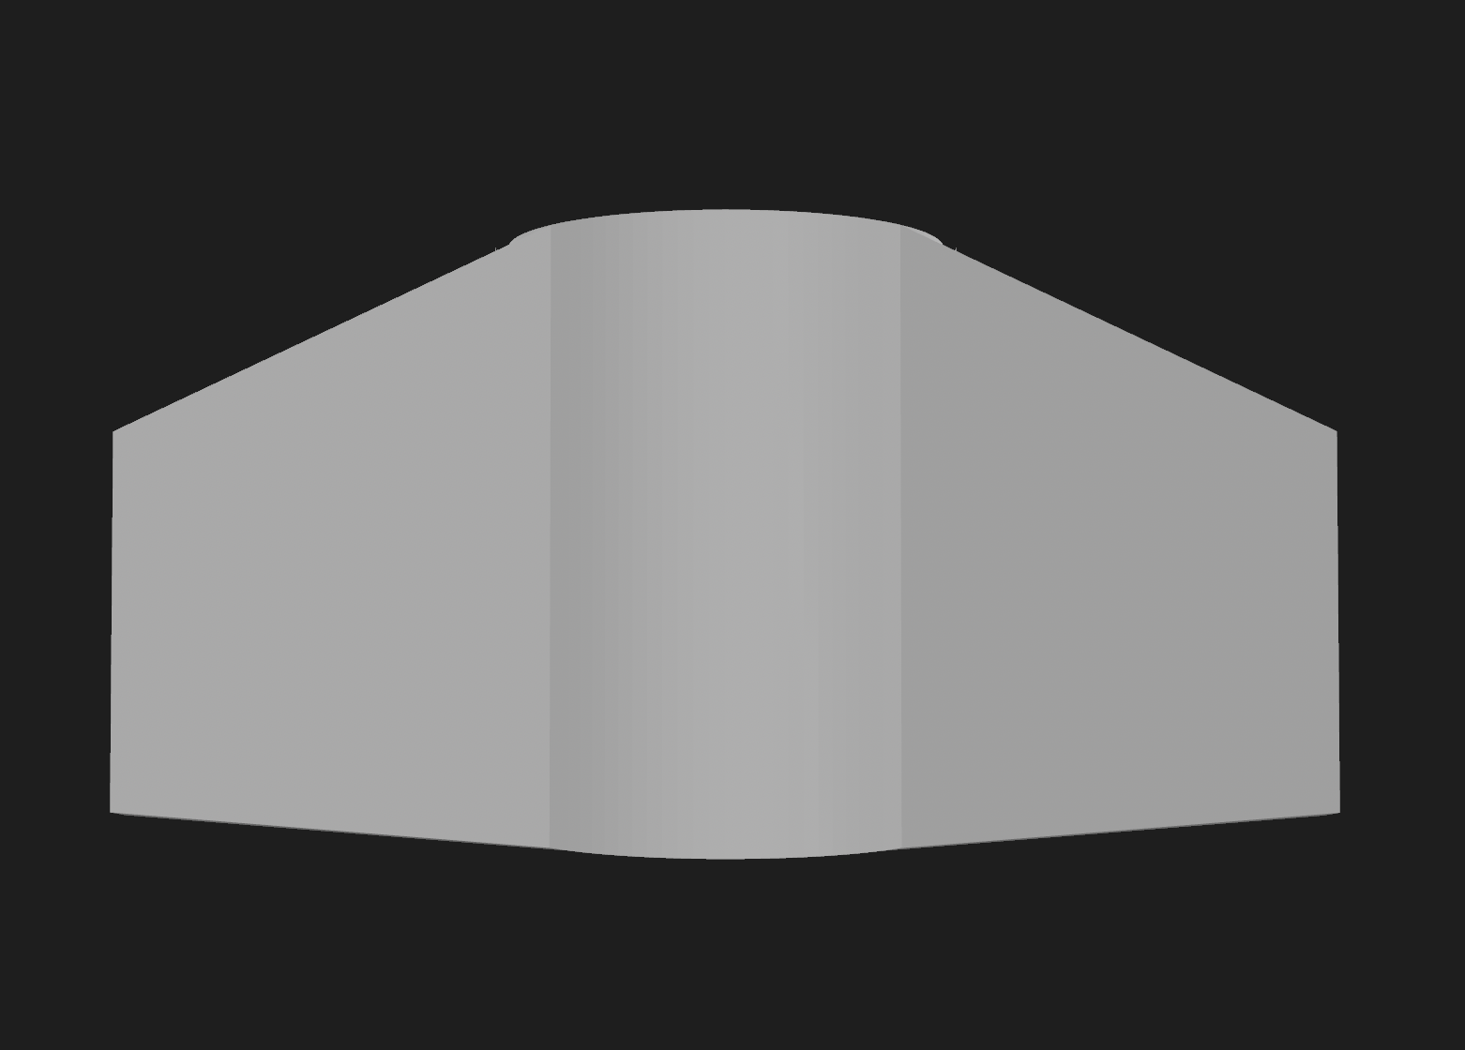
*Fin Profiles shown above as downward, then right view.

The flight fin employs a symmetric aerofoil cross-section sized to deliver the static margin identified above. Passive aerodynamics are established through three complementary channels: analytical prediction, direct wind-tunnel measurement, and flight validation.
Four fin cross-section profiles are fabricated for wind tunnel evaluation: a thin symmetric NACA profile (NACA 0006), a moderate symmetric NACA profile (NACA 0012), a double-wedge, and a flat-plate. Symmetric NACA section aerodynamic data referenced in Abbott and Von Doenhoff (1959) and the NACA 0012 characterization from NACA TN 2502 provide baseline expected performance for the NACA profiles at low angles of attack. All profiles are printed to identical planform dimensions so that only cross-sectional geometry varies between test articles. Low-Reynolds-number aerodynamic behavior of these profile types is framed using Lissaman (1983) and Mueller and DeLaurier (2003), both of which establish that profile geometry effects on lift and drag are particularly pronounced in the subsonic, low-Reynolds-number regime characteristic of the GTR70E WYVERN flight envelope.
For the computational cross-check, a constant-strength two-dimensional vortex-panel method following the Kuethe and Chow methodology solves the inviscid flow about each candidate section, returning lift coefficient and surface pressure distribution across the same sweep used in the tunnel campaign, plus a flat-plate skin-friction viscous-drag estimate so that lift-to-drag ratio is meaningful for section selection. The method is validated against thin-airfoil theory, returning a lift-curve slope close to the theoretical ideal with the expected inviscid thickness over-prediction. Because the panel method is inviscid, it captures circulation-driven lift and pressure distribution but not viscous separation, stall onset, or pressure drag; those come from the tunnel campaign, which is exactly what the computational model is built to be checked against.
For the analytical prediction, fin normal-force slope and center of pressure are computed by the Barrowman (1967) slender-body method with a body-interference correction, and zero-lift drag is built up componentwise from skin friction over the wetted area at the flight Reynolds number, base drag, forebody pressure drag, and fin profile drag, giving the nominal drag coefficient carried by the trajectory integrator. Reference low-angle-of-attack behaviour for symmetric sections of this class is benchmarked against the thin-airfoil and low-Reynolds-number frameworks of Lissaman (1983) and Mueller and DeLaurier (2003), and against tabulated section data from Abbott and Von Doenhoff (1959). Sensitivity of the predicted margin to build tolerance is quantified by a sweep across the plausible range of as-built center-of-gravity error, and the resulting margin, apogee, and drift distributions by Monte Carlo dispersion over the atmospheric envelope. An independent implementation of the same geometry in OpenRocket serves as a third-party cross-check on the center-of-pressure and trajectory prediction.
For flight reconstruction, two quantities are recovered from the onboard log and compared against both the analytical prediction and the tunnel measurement. Coast-phase drag coefficient is reconstructed from the deceleration between burnout and apogee, where thrust is zero and the only forces are drag and gravity, evaluated over the high-dynamic-pressure portion of the coast and averaged, with air density taken from the barometric altitude and the measured surface conditions. Static margin is reconstructed from the weathercock response: the observed steady pitch offset into the measured crosswind, together with the pitch-rate transient at rail exit, yields the aerodynamic restoring stiffness, from which the center of pressure follows given the measured center of gravity and dynamic pressure. Agreement between predicted and reconstructed values is the reported result for this research question; disagreement is itself a quantified finding about the predictive limits of a Barrowman-class model on a short, low-Reynolds-number, additively-manufactured airframe.

Flight Computer Systems & Avionics
All flight avionics functions, attitude estimation, control-law execution, actuator commanding, and data logging, are consolidated onto a single Raspberry Pi Pico 2 W, a dual-core microcontroller module carried on a hand-assembled prototyping board mounted as an axial card in the avionics bay. This replaces the distributed multi-board avionics architecture used in earlier program iterations. An intermediate revision of this design specified a custom circular printed circuit board built around a bare packaged die; that approach was retired on schedule grounds, since a fine-pitch quad-flat no-lead package requires a four-layer board with a continuous ground plane and the layout and fabrication turnaround did not fit the fixed launch window. Control-loop capability is unchanged, using the same silicon and the same core partition, and the change substantially reduces bring-up risk by making the avionics testable one breakout at a time rather than as a single monolithic board.
The two processor cores are functionally partitioned to preserve hard real-time determinism. The first core executes the 500 Hz thrust-vector-control loop exclusively, reading the inertial measurement units, computing nozzle deflection, evaluating the control law, and commanding the gimbal servos, and is permitted no blocking operations of any kind. The second core drains a logged-data ring buffer to a microSD card over a serial peripheral interface, isolating all non-deterministic input/output latency from the control path. This division directly addresses the principal failure mode of single-threaded flight-computer architectures, in which storage input/output can transiently block control-loop execution. Flight telemetry is logged to card as the data of record; the module’s onboard radio is used for bench telemetry on the ground test stand, where the same board and firmware image are reused with the bay inertial unit omitted.
Two nine-axis BNO085 inertial measurement units are deployed, one on the avionics board in the upper body tube and one mounted directly on the thrust-vector gimbal in the lower body tube, connected by a cable that crosses the bulkhead on separable leads. They are distinguished on a shared serial bus by their address-select pin. Each runs in a fusion mode combining accelerometer and gyroscope data with the magnetometer disabled, because the magnetic field generated by the adjacent gimbal servos would otherwise corrupt a magnetically-referenced heading estimate. The two units vote against each other for attitude fault detection, and because the second unit is gimbal-mounted, gimbal-relative deflection is measured directly in flight rather than only on the ground-test balances. At ejection the two body tubes separate and the gimbal unit disconnects with them by design; the firmware treats its loss after the deployment time as expected rather than as a fault, and descent attitude comes from the bay unit. A single barometric sensor (BMP388) on the same bus provides primary altitude tracking for the rocket, with a further BME688 utilized for extra environmental data.
The entire avionics domain runs off a light two-cell lithium-polymer pack through a resettable fuse and an arming switch into a switching regulator producing a single five-volt rail. That rail feeds the microcontroller, the storage breakout, and both gimbal servos, which are oversized for the computed gimbal torque demand; the sensors run off the microcontroller’s own regulator. A bulk electrolytic capacitor at the servo feed absorbs stall transients that would otherwise brown out the controller. Pack health is monitored by a resistive divider into an analog input, with firmware warning and critical thresholds set at conservative per-cell voltages. The arming switch is reached by removing the nose cone rather than through an airframe penetration.
The per-axis control law is a discrete proportional-integral-derivative controller with integral anti-windup clamping and a first-order low-pass-filtered derivative term, executed at 500 Hz with output clipped to an eight-degree gimbal deflection limit. That limit was raised from an earlier five degrees to give control-authority margin against crosswind weathercocking without adding passive fin stability, which would otherwise reduce the very disturbance the control system is built to demonstrate. The flight gain set was selected by a phase and gain margin analysis across twenty-four operating points and independently confirmed by a time-domain robust multi-wind auto-tune. It holds worst-case gust pitch deviation to under two degrees with wide gimbal headroom against the mechanical limit, while avoiding the resonance against finite servo lag observed in higher-proportional-gain configurations. The control loop is inhibited for the first half-second of flight, after which it engages to stabilize the vehicle to vertical and execute a small commanded maneuver.
Two thrust-vector-control actuator classes are evaluated using the identical control electronics, gimbal mechanism, and software control law, isolating actuator dynamics as the experimental variable: a tri-solenoid magnetic gimbal actuator and a servo-driven gimbal actuator. The comparison is conducted entirely on the ground-based three-axis thrust-vector load balances described below rather than in flight, to remove flight-to-flight aerodynamic and atmospheric variability from the actuator comparison. The flight vehicle itself carries the servo actuator, selected on the basis of the ground-comparison results.

Data Logging & Flight Test Plan
Comparative testing for Research Question 1 is conducted on the ground stands rather than in flight, with the control loop configured to drive each actuator class in turn: one series on the servo thrust-vector stand and a separate series on the physically separate magnetic thrust-vector stand. Logs record actuator command angle, achieved deflection, command-to-response latency, and peak deflection rate per degree of actuator input across the commanded range. The actuator class producing greater control authority for a given thrust regime is identified by comparing bandwidth, slew rate, overshoot, steady-state error, and maximum sustained deflection between the two stands. BPS.space TVC design references are used to benchmark expected authority against prior hobby-scale implementations. For Research Question 5, a minimum number of flight repetitions are completed for each candidate gain set, and post-flight telemetry is analyzed for percent deviation from the nominal trajectory, lateral displacement from the intended recovery point at parachute deployment, and peak attitude error during the powered flight phase.
All onboard sensor data is logged at the Raspberry Pi Pico 2 W’s sample rate and simultaneously downlinked via the onboard microSD card with critical data being transmitted by onboard WiFi telemetry when possible. Multiple flights are conducted with the control law configured under each candidate gain set, and post-flight telemetry recovered from the onboard log is analysed for peak pitch deviation during the powered phase, gimbal-angle utilization, and settling and overshoot behaviour, to determine which gain configuration produces the most accurate and best-damped attitude tracking. All onboard sensor data, including full-rate inertial, barometric, and control-loop telemetry, is logged at the full control-loop sample rate. Where a bench or range wireless link is in range, a parallel live feed is monitored for real-time anomaly detection, though the onboard log remains the data of record.

Recovery System
The vehicle’s passive fin stability is retained through the coast phase to apogee, predicted near 409 feet at approximately 6.7 seconds after launch. Recovery is initiated not by an independent electronic altimeter but by the flight motor’s own factory ejection charge. The flight configuration uses a motor with a four-second ejection delay, so that approximately four seconds after propellant burnout, roughly seven-tenths of a second past the predicted apogee, the motor’s integral ejection charge fires inside the lower body tube. Gas pressure builds directly against the bulkhead joint between the two body tubes, and the joint, friction-fit and shear-pinned to release at a target force, separates, deploying the parachute packed at the forward end of the lower body tube.
A first-order feasibility analysis supports the approach on two independent grounds. Flow-path losses at the ejection mass-flow rate are negligible against the driving pressure. The recovery bay pressurizes to roughly an order of magnitude above the friction-fit joint-release threshold, giving a pressurization margin of several times. The four-second delay is the closest available factory delay to the coast-to-apogee optimum; longer available delays are rejected because they fire well past apogee, deploying at high descent speed and, in the longest case, at dangerously low altitude.
This motor-ejection architecture needs no independent recovery computer, no isolated recovery battery, no electric match or black-powder charge, and no dedicated recovery wiring, reducing parts count, cost, and an entire electronic failure domain, at the cost of a single passive deployment event with no electronic backup channel. That trade is justified by the pressurization margin and by the finned airframe’s aerodynamic stability through apogee. Shock-cord and parachute sizing, using tubular aramid cord and a 24-inch ripstop nylon canopy with an aramid blanket shielding the canopy from the ejection gas, are verified against the worst-case deployment scenario, giving a harness structural safety factor comfortably above target. A predicted terminal descent rate near five metres per second follows once the canopy is fully open.
All electrical connections crossing the bulkhead, the two servo leads and the gimbal inertial unit cable, are made on separable male-female extension leads that simply pull apart at separation, so the aramid shock cord is the only retained link between the two halves. The firmware treats the resulting loss of the gimbal sensor and servo power as an expected consequence of deployment rather than as a fault condition.

Simulations, Firmware, and Modelling
All flight computer firmware is written in C++ and developed within the Arduino IDE using the Arduino-Pico core, targeting the Raspberry Pi Pico 2 W. The firmware implements a multi-input PID control loop that reads IMU attitude quaternion estimates, computes attitude error relative to the pre-loaded nominal trajectory, and outputs servo commands to the two gimbal actuators. Multiple candidate gain sets are evaluated for Research Question 5, including a step-response-tuned baseline and a simulation-refined set validated across modelled atmospheric and gust conditions. Gain values for each configuration are tuned iteratively using the Ziegler-Nichols (1942) step-response tuning method and refined against a phase and gain margin sweep. TVC control architecture design draws on the low-cost launcher guidance framework described by Gordillo et al. (2023) and on NASA TN D-4971 (1968) for fundamental TVC authority and control allocation requirements in solid-propellant systems. OpenRocket is used for pre-flight stability analysis, center-of-pressure and center-of-mass tracking across motor burn, and nominal trajectory prediction per the OpenRocket technical documentation (2023), with simulated outputs compared against flight telemetry as a cross-validation metric.

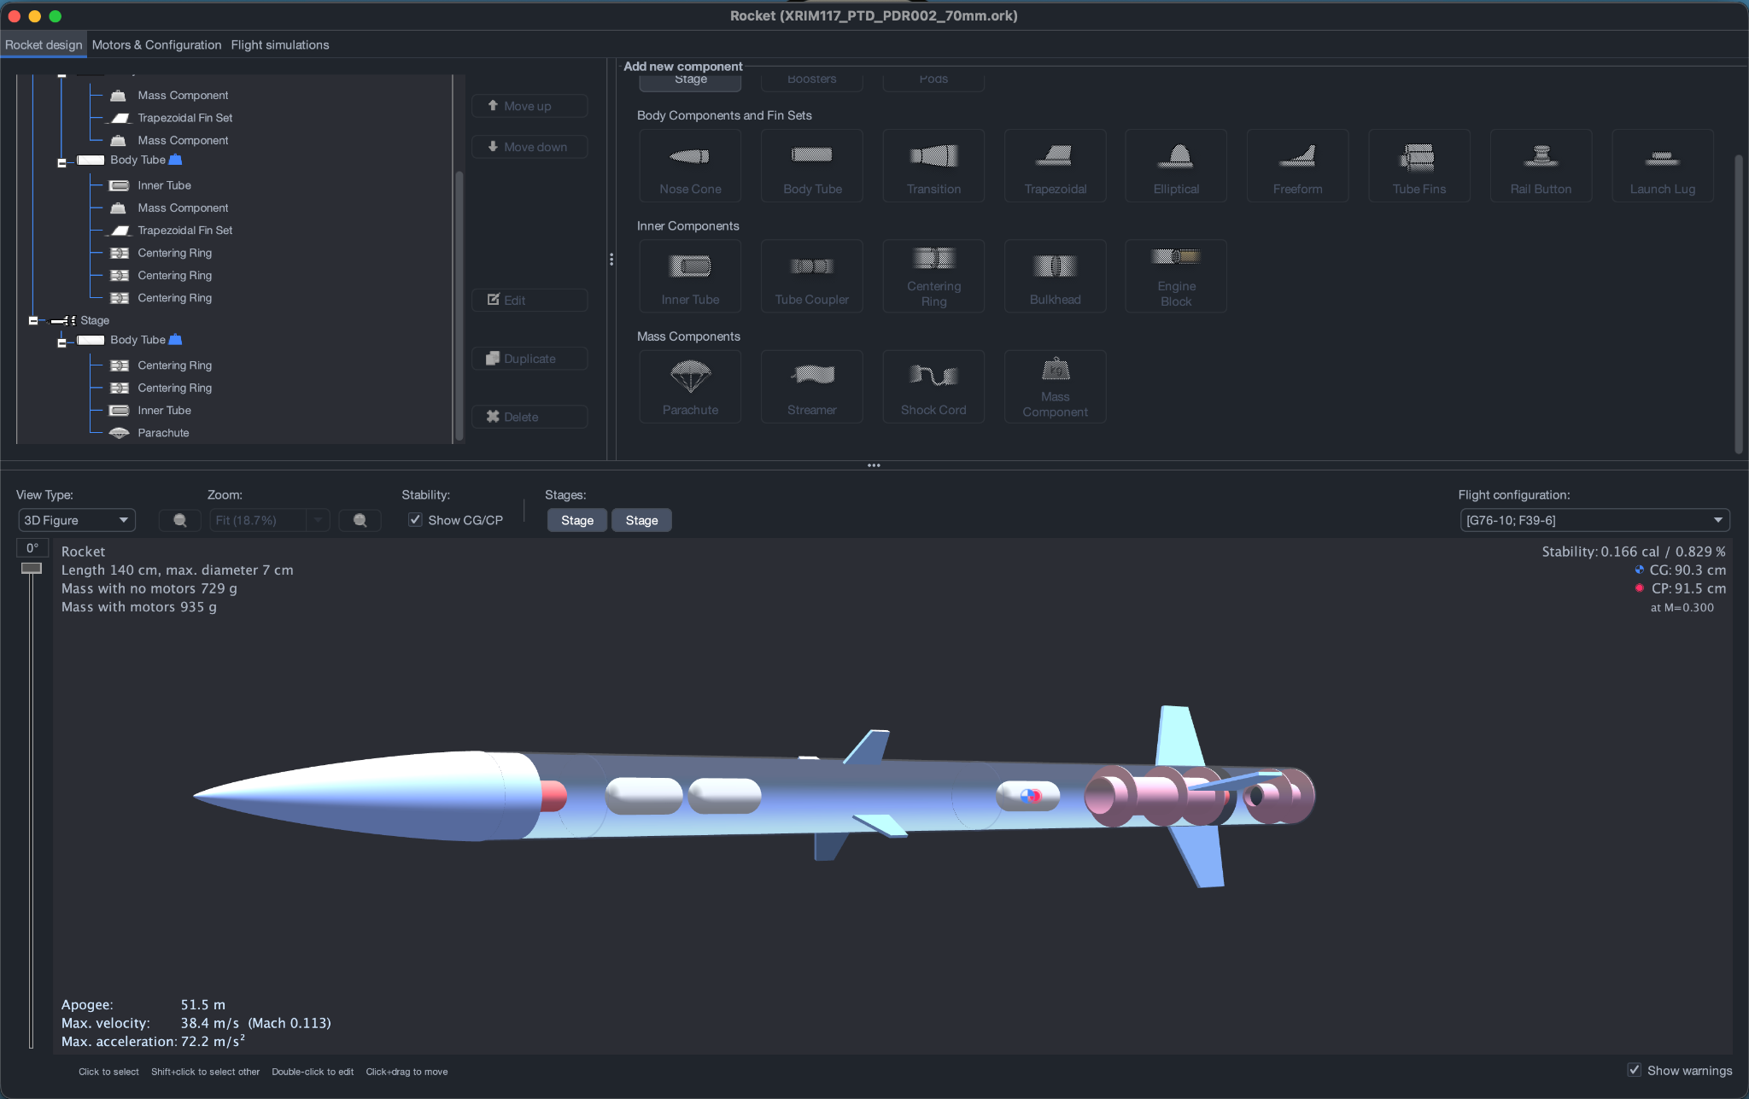
*OpenRocket Model with Stability and Approximate Dimensions

Ground Fire Test Program
Four purpose-built stands are constructed: a servo thrust-vector stand, a physically separate magnetic thrust-vector stand, a static-fire stand handling calibration, thrust curves, and the blast-shield materials screen, and a bench wind tunnel for aerofoil measurement. The three motor-fired stands are fully printable in carbon-filled polyethylene terephthalate glycol, selected for its motor-plume thermal margin, and instrumented with strain-gauge load cells and twenty-four-bit bridge-amplifier breakouts, logged to onboard storage by a dedicated data-acquisition microcontroller independent of the flight avionics. The wind tunnel is an unpowered bench rig with its own instrumentation.
Each actuator class is mounted to its own physically identical thrust block, restrained from a fixed base by three strain-gauge load cells acting through flexures, one axial and two lateral, resolving the complete thrust vector in both magnitude and direction. The cells are sized to the expected loading envelope of the test motor, using a five-kilogram axial cell and two one-kilogram lateral cells digitized at eighty samples per second, identically on both stands. An alternative single-piece design, a cruciform flexure instrumented with one bridge per arm forming a unified three-axis force sensor, is held as a fallback configuration should the discrete three-cell assembly prove difficult to align. Running the identical instrumentation chain on two separate physical stands, rather than swapping actuators on one shared fixture, is what makes the magnetic-versus-servo comparison valid under nominally identical thrust conditions. Commanded-versus-measured deflection angle is logged across a series of step and ramp commands under identical thrust conditions on each stand to extract bandwidth, slew rate, step-response overshoot, steady-state error, and maximum sustained deflection for each actuator. Because each firing provides only a few seconds of control window, the independent command set for each actuator system is built up across multiple firings on its respective stand.
The static-fire stand is a single-axis, load-cell-only stand fitted with a steel blast deflector. It validates the as-fired thrust curve of every motor class used in the program against its published specification, and carries a thermocouple on the engine-bay wall to measure the peak temperature that the materials heat-deflection argument depends on. The blast-shield materials screen runs on this same stand: a flat coupon plate of each candidate material, five millimetres thick at full density, is mounted directly in the exhaust path and fired on. Six materials go through the screen, and the measured response is melt-through, ablation depth, and slag buildup rather than thrust or deflection. Materials surviving five millimetres are retested at four, then three, then two millimetres until they fail, feeding the materials dataset as a failure-thickness ranking. Ground firings use a plugged, zero-delay variant of the flight motor, which has an identical thrust curve but no ejection charge, so that nothing fires into the stand fixtures after burnout.
Planned firing counts are four flight motors for flight testing, and between thirteen and twenty-four plugged ground motors: six across the two thrust-vector stands at three firings per actuator system, two on the static-fire stand for thrust-curve verification and the engine-bay wall temperature measurement, and the blast-shield screen, which is adaptive rather than fixed. Six materials at up to four thickness steps each tops out at twenty-four firings if every material survives to two millimetres, though most candidates are expected to fail by four millimetres in practice, so the realistic budget is roughly twelve to sixteen firings with twenty-four as the worst case. A further six low-cost motors are budgeted for stand commissioning at two firings per motor-fired stand.
Each stand’s load cells are first calibrated independently of any motor firing, using a series of known hanging dead weights spanning the expected force range, to establish a force-to-voltage transfer function for every channel. Each stand is then commissioned with a minimum of two low-cost motor firings before any data-collection firing is conducted, to validate the as-built stand’s measured thrust curve against the motor’s independently published reference curve and confirm that structural compliance in the stand itself is not corrupting the force measurement. Only after a stand passes this commissioning check are data-collection firings conducted on it. All raw and reduced ground-test data are archived in the same repository used for flight data release.

Wind Tunnel
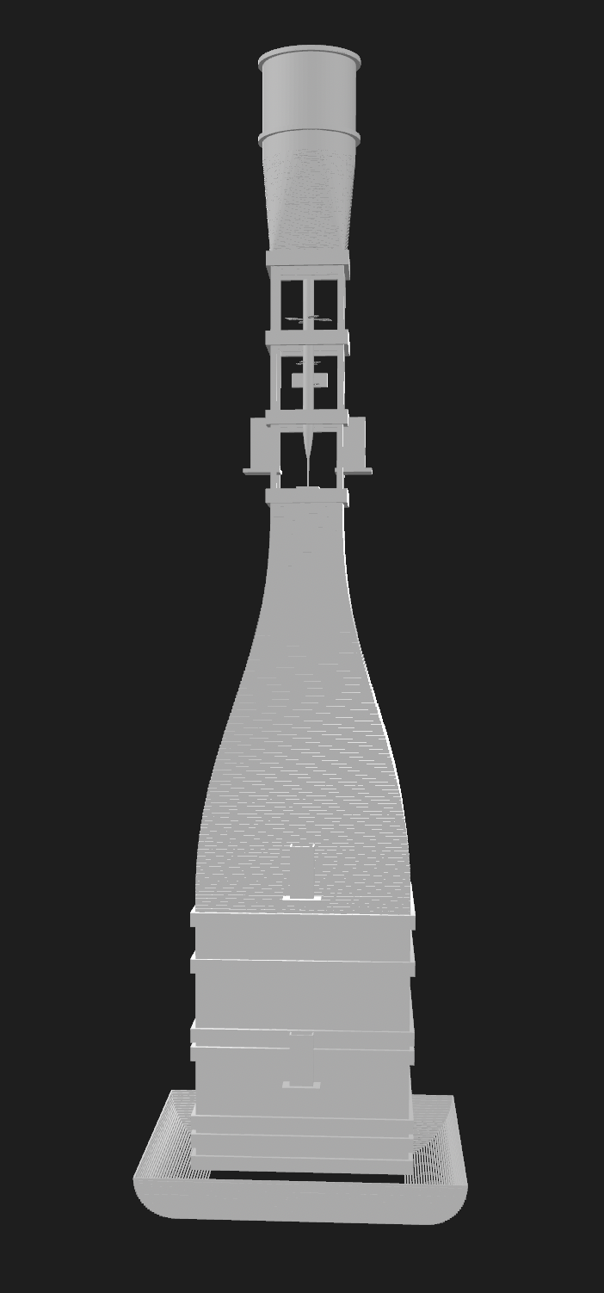
*Initial 3D Model of the low-speed open-return wind tunnel system

The custom open-return wind tunnel is designed per the Hofferth (2025) AIAA SciTech modular configuration and comprises a bell-mouth inlet, a flow-conditioning section with honeycomb and mesh screens, a converging contraction section designed per Bell and Mehta (1988) area ratio and length criteria, an optically accessible test section, and a diffuser leading to a variable-speed fan unit. Tunnel design also draws on the low-speed tunnel design rules of Mehta and Bradshaw (1979) and the reference design methodology of Pope and Harper (1966). Prior to aerodynamic testing, the tunnel is characterized across its full operating range using a Pitot-static probe traversed across the test section cross-section at multiple fan speed settings to map freestream velocity and spatial uniformity, with a uniformity target of less than 2% RMS variation in the core flow region. Blockage corrections are applied to all measured drag coefficients using the Maskell (1963) bluff-body blockage correction method. Reynolds number similarity ratios between tunnel conditions and powered-ascent flight conditions are computed to identify the fan operating point at which tunnel aerodynamic loading on the scaled rocket model most closely replicates predicted loading on the full-scale vehicle during powered ascent.
Each fin profile test article is mounted on a two-axis force balance string within the test section and lift and drag forces are recorded at equal angle-of-attack increments from 0° through post-stall at the calibrated Reynolds-matched condition. Lift coefficient, drag coefficient, lift-to-drag ratio, and stall onset angle are extracted for each profile, with a minimum of three repeated runs per angle per profile conducted to assess measurement repeatability. Mean values from repeated runs are used for all cross-profile comparisons. Each fin article is additionally tested at representative ascent airspeeds with deflection inputs applied in 2° increments to characterize deflection-normalized lift increment as a function of airspeed, providing the ground-based component of the aerofoil performance comparison addressed in Research Question 3. Airfoil section data from Selig (2003) and Selig et al. (1989) are used as reference benchmarks against which tunnel-measured coefficients for the NACA profiles are validated prior to cross-profile comparison.

Safety & Compliance
All flights are conducted in compliance with NAR (2023) safety code and motor classification standards, with a NAR representative or similarly qualified adult present at each flight session. All flights use a single Estes F15-4 motor, an F-class motor with a four-second ejection delay, and the fully loaded liftoff mass of approximately 720 grams is well under the Federal Aviation Administration’s Class 1 model rocket threshold of 1,500 grams loaded weight per motor, requiring no airworthiness waiver and no high-power certification. Range procedures include remote ignition, a minimum three-metre personnel standoff from both ground-test stands during firing, a fail-safe neutral-gimbal default state on any control-system fault, and standard model-rocketry motor-handling discipline for the motor’s integral ejection charge. The igniter is installed last, at the pad, and there are no independent pyrotechnic or electronic ejection circuits in the vehicle to arm or inhibit, since recovery is effected solely by the motor’s own delay and ejection charge.

Expected Outcomes

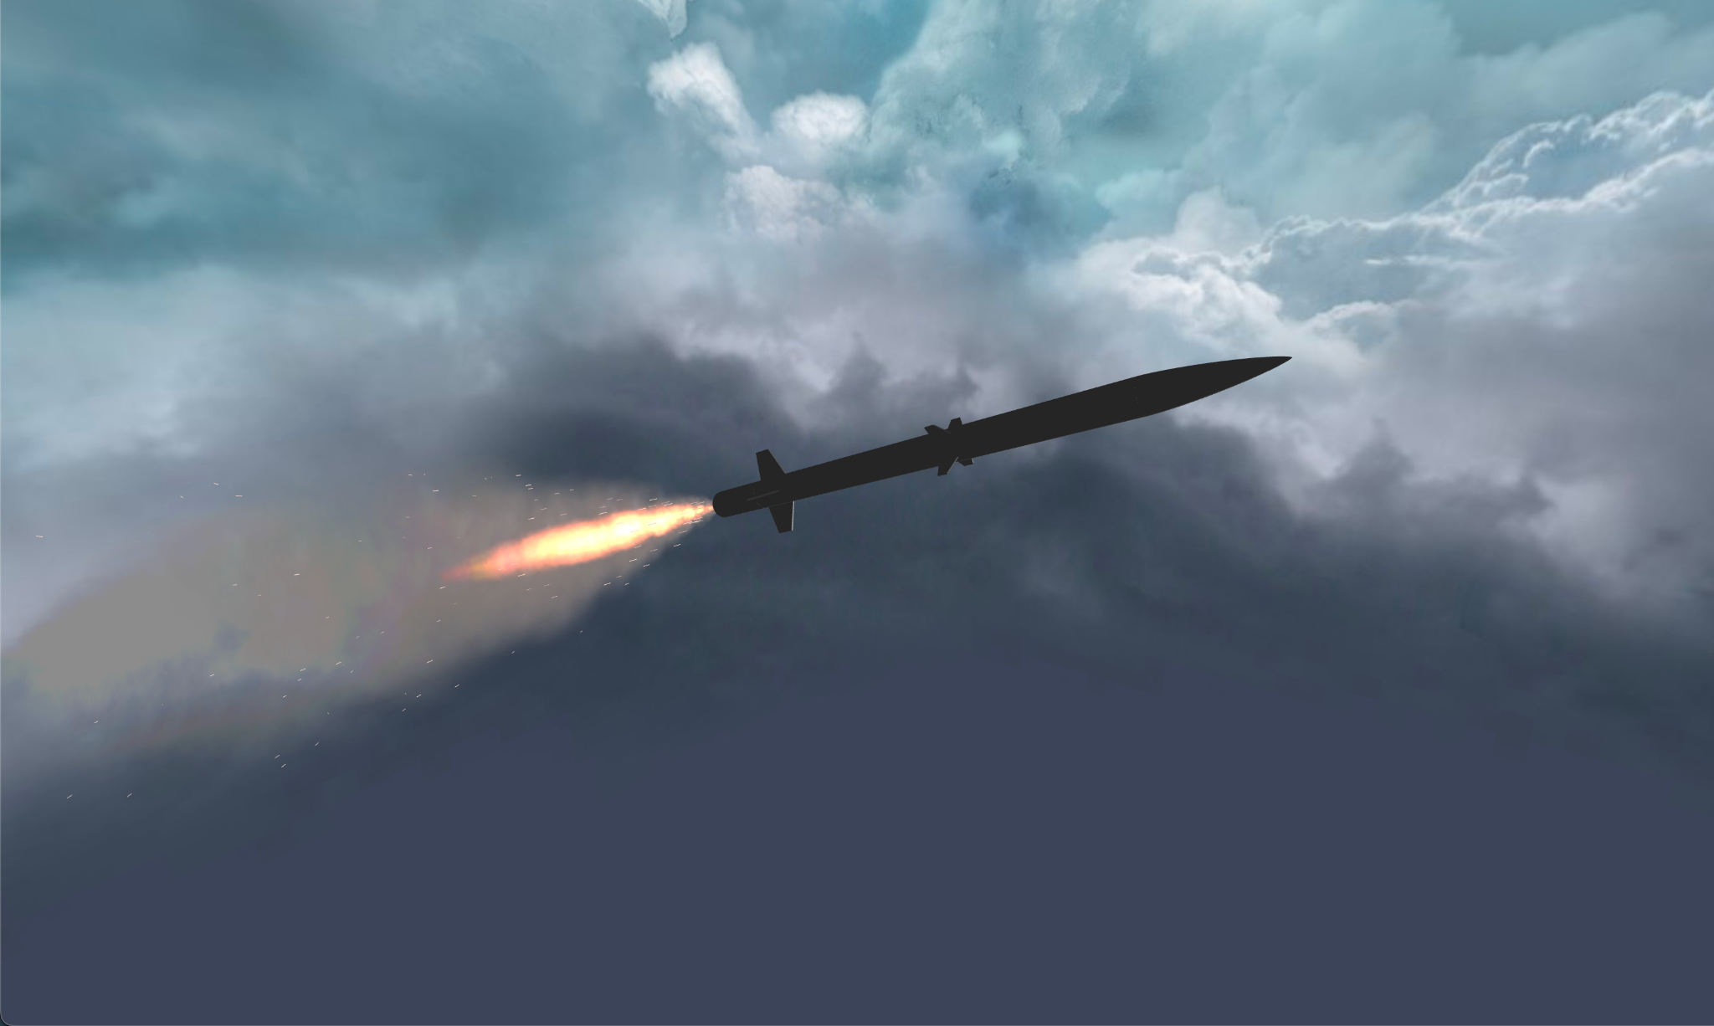
*OpenRocket Render of the GTR70E WYVERN in Flight

We expect to see a few possible outcomes from our research and prototyping journey. We will be able produce a quantitative, ground-validated comparison of magnetic-solenoid and servo thrust-vector-control actuators, including bandwidth, slew rate, overshoot, and steady-state error for each, directly informing actuator selection for future closed-loop rocketry programs without requiring a dedicated in-flight comparison.
We will also be able to identify the optimal material for hobbyist manufacturing utilizing 3D printing for rapid prototyping and defining which has the best stiffness, print quality, and overall durability, something not as commonly addressed in rocketry literature which tends to prefer wood, ceramic, or fiberglass construction. In addition we are looking into the aerofoil profiles and will be able to experimentally determine which of them produces the most attitude control in an actively deflected configuration at low Reynolds numbers, with recorded wind tunnel and simulation data being released as an open-source dataset. The development of the GTR70E WYVERN testing wind tunnel will give the rocketry community a cost effective and open-source option for ground-based simulation, powered ascent simulation, and live testing of aerodynamics and control theory. It will also further expand on that control theory by evaluating the complexity of control and the performance regimens that can be achieved with different levels of microprocessor and loop complexity. We hope to be able to release all data as publicly available datasheets through a public repository and develop the rocket components into either fledged out products or reproducible systems; still committing to full open-source designs and data sharing.

References

Abbott, I. H., & Von Doenhoff, A. E. (1959). Theory of wing sections: Including a summary of airfoil data. Dover Publications. https://store.doverpublications.com/0486605868.html
Barrowman, J. S. (1967). The practical calculation of the aerodynamic characteristics of slender finned vehicles (NASA NTRS accession 20010047838). https://ntrs.nasa.gov/citations/20010047838
Barrowman, J. S. (1967). The theoretical prediction of the center of pressure. Apogee Rockets. https://www.apogeerockets.com/downloads/barrowman_report.pdf
Bell, J. H., & Mehta, R. D. (1988). Contraction design for small low-speed wind tunnels (NASA CR-182747). https://ntrs.nasa.gov/api/citations/19880012661/downloads/19880012661.pdf
Bhandari, S., Lopez-Anido, R. A., & Gardner, D. J. (2019). Enhancing the interlayer tensile strength of 3D printed short carbon fiber reinforced PETG. Composites Part B: Engineering, 179, 107542. https://doi.org/10.1016/j.compositesb.2019.107542
BPS.space. (n.d.). Thrust vector control. BPS.space. Retrieved April 18, 2026, from https://bps.space/products/thrust-vector-control
Chacón, J. M., Caminero, M. A., García-Plaza, E., & Núñez, P. J. (2017). Additive manufacturing of PLA structures using fused deposition modelling. Composite Structures, 182, 107–116. https://doi.org/10.1016/j.compstruct.2017.09.004
Dizon, J. R. C., Espera, A. H., Chen, Q., & Advincula, R. C. (2018). Mechanical characterization of 3D-printed polymers. Additive Manufacturing, 20, 44–67. https://doi.org/10.1016/j.addma.2017.12.002
Estes Industries. (n.d.). F15 model rocket engine, technical specifications.
Federal Aviation Administration. (n.d.). Title 14 CFR Part 101, Subpart C, Amateur rockets.
Hofferth, J. (2025). Modular wind tunnel for STEM education. AIAA SciTech 2025 Forum. https://doi.org/10.2514/6.2025-2630
Hsueh, M.-H., Lai, C.-J., Liu, K.-Y., Chung, C.-F., Wang, S.-H., Pan, C.-Y., Huang, W.-C., Hsieh, C.-H., & Zeng, Y.-S. (2021). Effects of printing parameters on the thermal and mechanical properties of 3D-printed PLA and PETG. Polymers, 13(13), 2092. https://doi.org/10.3390/polym13132092
Kuethe, A. M., & Chow, C.-Y. (1998). Foundations of aerodynamics: Bases of aerodynamic design (5th ed.). John Wiley & Sons.
Lissaman, P. B. S. (1983). Low-Reynolds-number airfoils. Annual Review of Fluid Mechanics, 15, 223–239. https://bpb-us-w1.wpmucdn.com/sites.usc.edu/dist/4/81/files/2023/05/lissaman-arfm-1983.pdf
Liu, Y., & Hui, W. (2024). Implementation and verification of a micro-jet-vane system of a solid rocket motor for a micro-nano satellite. Aerospace, 11(5), 367. https://www.mdpi.com/2226-4310/11/5/367
Mahony, R., Hamel, T., & Pflimlin, J.-M. (2008). Nonlinear complementary filters on the special orthogonal group. IEEE Transactions on Automatic Control, 53(5), 1203–1218. https://hal.science/hal-00488376v1/document
Maskell, E. C. (1963). A theory of the blockage effects on bluff bodies and stalled wings in a closed wind tunnel (ARC R&M 3400). Aeronautical Research Council. https://reports.aerade.cranfield.ac.uk/handle/1826.2/3452
Mehta, R. D., & Bradshaw, P. (1979). Design rules for small low speed wind tunnels. Aeronautical Journal, 83(827), 443–449. https://doi.org/10.1017/S0001924000031985
Mueller, T. J., & DeLaurier, J. D. (2003). Aerodynamics of small vehicles. Annual Review of Fluid Mechanics, 35, 89–111. https://doi.org/10.1146/annurev.fluid.35.101101.161102
Murty, M. S. R., & Chakraborty, D. (2015). Numerical characterisation of jet-vane based thrust vector control systems. Defence Science Journal, 65(4), 263–270. https://www.researchgate.net/publication/283661759_Numerical_Characterisation_of_Jet-Vane_based_Thrust_Vector_Control_Systems
National Advisory Committee for Aeronautics. (1951). Aerodynamic characteristics of NACA 0012 airfoil section at angles of attack from 0° to 180° (NACA TN 2502). https://ntrs.nasa.gov/citations/19930082895
National Association of Rocketry. (2023). NAR safety code and motor classification standards. https://www.nar.org/safety-information/
NASA. (1968). Thrust-vector control requirements for solid-propellant launch vehicles (NASA TN D-4971). https://ntrs.nasa.gov/api/citations/19680019218/downloads/19680019218.pdf
OpenRocket Project. (2023). OpenRocket technical documentation v23.09. https://openrocket.info/documentation.html
Pérez Gordillo, A., Simplício, P., Iannelli, A., & Marcos, A. (2023). Thrust vector control and state estimation architecture for low-cost small-scale launchers. arXiv. https://arxiv.org/pdf/2303.16983
Pillay, S., Vaidya, U. K., & Janowski, G. M. (2009). Effects of moisture and UV exposure on liquid molded carbon fabric reinforced nylon 6 composite laminates. Composites Science and Technology, 69(6), 839–846. https://doi.org/10.1016/j.compscitech.2008.11.012
Popescu, D., Zapciu, A., Amza, C., Baciu, F., & Marinescu, R. (2018). FDM process parameters influence over the mechanical properties of polymer specimens. Polymer Testing, 69, 157–166. https://doi.org/10.1016/j.polymertesting.2018.05.020
Pope, A., & Harper, J. J. (1966). Low-speed wind tunnel testing. Wiley. https://archive.org/details/lowspeedwindtunn0000pope
Precision Ceramics. (2021). Macor machinable glass ceramic — technical data sheet. https://precision-ceramics.com/wp-content/uploads/2021/06/Macor_Technical_Data_Sheet.pdf
Raspberry Pi Ltd. (2024). Raspberry Pi Pico 2 W datasheet.
Sahoo, S. (2026, April 11). (Skylight Industries, Ed.). WYVERN PTD Portal; Skylight Industries. https://GTR70E WYVERN.base44.app/
Selig, M. S. (2003). UIUC airfoil data site. University of Illinois at Urbana-Champaign. https://m-selig.ae.illinois.edu/ads.html
Selig, M. S., Donovan, J. F., & Fraser, D. B. (1989). Airfoils at low speeds (Soartech 8). SoarTech Publications. https://m-selig.ae.illinois.edu/ads/afplots/airfoils_at_low_speeds.pdf
Ziegler, J. G., & Nichols, N. B. (1942). Optimum settings for automatic controllers. Transactions of the ASME, 64, 759–768. https://davidr.no/iiav3017/papers/Ziegler_Nichols_%201942.pdf

Past Abstracts

Swaroop Sahoo

Evaluating the Efficiency, Practicality, and Effectiveness of Emission/Reception-Capable LiDAR and RaDAR Detection Systems in Autonomous Navigation
Autonomous vehicles are swiftly evolving from experimental prototypes to a social norm. Advanced emitter-based sensor technologies, including LiDAR and RaDAR, are at the heart of these developments. This research has explored, through an analysis of raw performance, which is best for autonomous navigation systems. With an R2 Smart Car, we had extensive testing with the setup to ascertain detection capability across various terrains and conditions. We hypothesized that if an autonomous vehicle employs LiDAR sensors rather than RaDAR sensors, it will realize better detection owing to its higher resolution, precision, and finer performance for short-range distances. During our trials, LiDAR always outperformed RaDAR concerning precision and the recognition of objects within close and medium ranges. However, RaDAR showed better performance in adverse weather conditions, proving that it is more resistant to environmental stressors. Despite LiDAR's superior detection performance, several challenges were identified: higher cost, greater energy demands, and limited field of view. RaDAR, though less effective in performance, claims advantages regarding cost-efficiency, weather robustness, and lower battery requirements. These considerations become critical in balancing efficiency against function while designing a self-driving vehicle. This experiment shows that such a multi-sensor approach is needed to put together the strengths of LiDAR and RaDAR to attain maximum detection accuracy and system reliability. Such integration will be imperative for making robust, cost-effective autonomous systems that are capable of navigating diverse real-world conditions and thereby fostering the feasibility and safety of autonomous vehicles in mainstream society.

Chris Liu

In-Situ resource utilization-derived iron perchlorate redox flow battery for Mars: electrolyte characterization and extreme cold performance validation
Sustained habitation on Mars demands robust energy storage systems capable of reliable operation under extreme cold, especially during night and dust storm periods that render conventional lithium-ion batteries ineffective. This work introduces an in-situ resource utilization (ISRU) strategy for constructing iron perchlorate redox flow batteries, fully leveraging Martian-available materials to achieve extreme cold resilience. Eutectic freezing points and ionic conductivities of three Martian-available electrolytes (iron sulfate, iron chloride, and iron perchlorate) were systematically characterized. Iron perchlorate aqueous solution at 45 wt% displayed a eutectic freezing point of −78 °C, outperforming iron chloride (−55 °C) and iron sulfate (−10 °C). Laboratory-scale single cells were developed via computer-aided design and 3D printing, then tested under simulated Martian low-temperature conditions. The iron perchlorate system maintained 56% of its room-temperature capacity at −50 °C and remained operational at −70 °C, while iron chloride cells retained only 25% at −50 °C and lost functionality at lower temperatures. Electrochemical impedance measurements revealed that, although electrolyte resistance increases at lower temperature, charge transfer resistance becomes the dominant limiting factor under extreme cold. The results establish that ISRU-derived iron perchlorate flow batteries offer a feasible, cold-resilient solution for reliable energy storage in future Mars surface operations and settlement, with further performance gains likely through advanced perchlorate brine formulation.

Allison Hong

The Effects of Different Types of Synthetic Retinoids on Bacteria Inhibition: Antibacterial Properties
Retinoids are a group of compounds including naturally occurring and synthetic vitamin A metabolites and analogs. The two most common synthetic vitamin derivatives are Tretinoin and Adapelene. This experiment aims to determine the inhibitory properties of Adapalene and Tretinoin on Escherichia Coli. K-12. We hypothesized that the tretinoin group would have a greater inhibitory effect than the adapalene group. We created agar petri dishes and swabbed E. coli. The dishes were incubated for six days in total. Adapalene Gel 0.1% and Tretinoin Gel 0.1% were measured and diluted with Methyl Alcohol. The solutions were added on day two of incubation. The bacterial growth was counted after the incubation period for the number of colonies formed on each dish. The retinoids, especially adapalene, were found to promote the growth of bacteria instead of inhibiting its growth. The data of all three groups represent a polynomial regression, with adapalene and tretinoin exhibiting an exponential pattern and the control group exhibiting a logarithmic pattern. Each result was evaluated with the statistical analysis of a t-test, and all data was significant and not random. Further research is suggested to better understand the retinoids’ effects on bacterial growth and inhibition.

